Agentic AI is transforming industries, delivering measurable improvements in efficiency, insight, and scalability. In 2025, an estimated 35% of organizations plan to deploy AI agents, with adoption projected to reach 86% by 2027. [1] As adoption accelerates and Agentic AI systems, capable of independent, objective-driven action, take on complex and high-stakes tasks, using a Human-in-the-Loop (HitL) approach becomes critical. HitL Agentic AI ensures that while machines operate autonomously, human oversight is embedded at key decision points to safeguard reliability, ethics, and compliance in AI systems.
Let’s explore why a HitL model is essential for Agentic AI implementations, especially in high-stakes scenarios, and how organizations can practically maintain human-AI balance.

Why Human-in-the-Loop is Crucial for Agentic AI Implementations
Agentic AI excels at automating complex workflows, analyzing vast datasets, and making rapid decisions. However, their autonomy introduces risks, ranging from subtle biases to errors, especially when deployed in domains, such as healthcare, finance, or legal services.
Key risks of unchecked AI autonomy:
- Ethical lapses: AI can optimize for efficiency but overlook societal norms or individual rights.
- Security threats: Autonomous agents can be manipulated or exploited by malicious actors, leading to misuse or unintended consequences.
- Lack of contextual judgment: AI often lacks the nuance and empathy required for ambiguous or sensitive situations.
- Regulatory non-compliance: Automated AI decision-making can inadvertently violate laws or industry standards, exposing organizations to legal and reputational harm.
A Human-in-the-Loop approach addresses these risks by embedding human judgment, validation, and intervention into the AI agent lifecycle — from design and training to deployment and ongoing operation.

How Human-in-the-Loop Ensures Reliable and Ethical Outcomes

Strategic Oversight in High-Stakes Scenarios
In high-stakes environments, human oversight is a critical checkpoint, ensuring that AI decisions align with organizational values, ethical standards, and regulatory requirements.
Examples:
- Healthcare: AI agents can pre-screen medical images for anomalies, but physicians review and confirm diagnoses to prevent misdiagnoses and ensure patient safety.
- Finance: AI agents for finance can flag suspicious transactions or recommend loan approvals, but human underwriters review these decisions for compliance and fairness, mitigating bias and ensuring regulatory adherence.
- Legal Services: Legal AI agents can prioritize cases or flag potential threats, but officers make the final call, applying contextual and ethical judgment.

Real-Time Error Correction and Feedback Loops
Even the most advanced AI agents can make mistakes. HitL enables humans to catch and correct errors early, preventing them from cascading into larger failures. This is especially vital in domains where a single error can have severe consequences, such as patient privacy breaches or financial fraud.

Bias Mitigation and Model Refinement
Agentic AI systems are only as unbiased as the data and logic they’re built on. Human reviewers can spot skewed outputs, provide corrective feedback, and help retrain models, reducing the risk of systemic bias. Reinforcement Learning from Human Feedback (RLHF) is used to align agentic AI behavior with human values and organizational goals.

Trust, Transparency, and Explainability
Stakeholders are more likely to trust Agentic AI systems when they know humans are monitoring, validating, and able to intervene. Explainable AI (XAI) tools further empower human overseers by clarifying why the AI agent made a particular decision, supporting auditability and regulatory compliance.
Figure 1: High-Stakes Use Cases: Why Human Oversight Matters
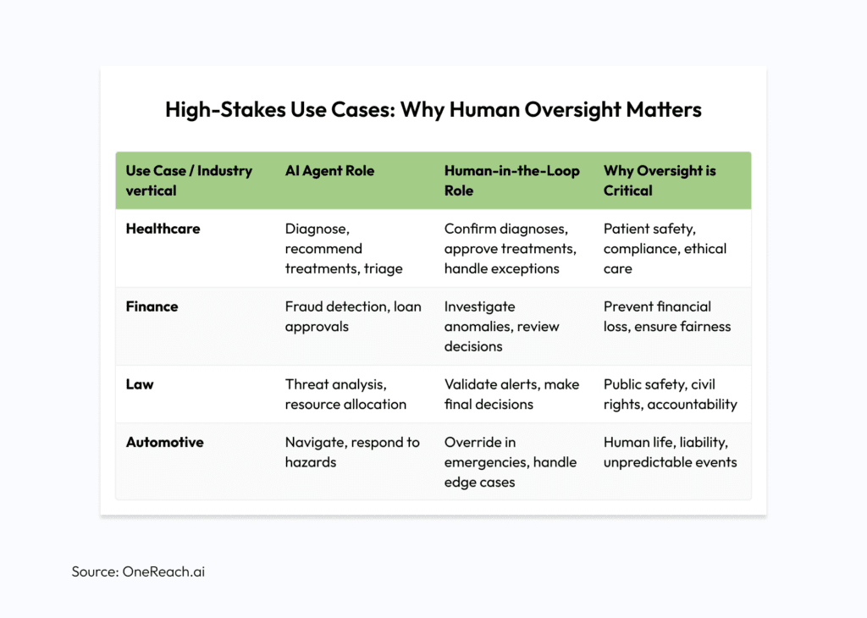

Practical Strategies for Implementing Human-in-the-Loop with Agentic AI

Tiered Oversight
- Routine tasks can be handled autonomously by AI, while high-stakes or complex cases automatically trigger human review.
- Example: In customer service, AI agents resolve common queries, but escalate sensitive or unresolved issues to human agents.

Explainable AI (XAI) and Audit Trails
- Use XAI tools to ensure human overseers understand AI decision logic, supporting transparency and compliance.
- Maintain audit trails for all AI-driven decisions, enabling post-hoc analysis and regulatory reporting.

Training and Empowerment
- Equip human overseers with AI literacy, intuitive dashboards, and authority to intervene or override AI actions.
- Regularly update training to reflect evolving AI capabilities and regulatory requirements.

Adaptive Autonomy
- Design systems where AI autonomy dynamically adjusts based on context, risk, or confidence levels.
- Example: An autonomous vehicle can operate independently in clear conditions, but yield control to a human driver in complex or dangerous scenarios.

Continuous Feedback and Model Improvement
- Integrate RLHF and other feedback mechanisms to ensure Agentic AI systems learn from human expertise and adapt to new challenges.

AI Ethics, Explainability, and Compliance: The Pillars of Responsible Human-in-the-Loop
As regulatory frameworks, such as the EU AI Act [2] increasingly require human oversight for high-risk Agentic AI systems, organizations must ensure their agentic AI deployments are not only effective but also ethical and compliant. HitL is foundational to:
- AI Ethics: Embedding human values, fairness, and accountability into AI-driven processes.
- Explainable AI: Making AI decisions transparent and understandable for both users and regulators.
- Compliance: Ensuring all AI actions adhere to industry regulations, privacy laws, and organizational policies.

OneReach.ai GSX Agent Platform: Human-in-the-Loop Capability for Agentic AI Solutions
OneReach.ai’s GSX platform enables organizations to create and orchestrate tailored Agentic AI solutions with built-in Human-in-the-Loop (HitL) capability. The GSX platform empowers teams to:
- Seamlessly escalate conversations or decisions from AI agents to human experts in real time.
- Allow human agents to monitor, validate, and intervene in ongoing automated processes, ensuring quality and compliance.
- Establish feedback loops where human input and corrections directly inform future AI behavior, driving continuous improvement.
This approach is especially valuable in contact centers, customer support, and other high-touch environments where the stakes of a misstep can be significant. By blending automation with human empathy and expertise, organizations can achieve both scalable efficiency and trustworthy outcomes.

The Future of Human-AI Collaboration
While AI autonomy is advancing fast, full automation, especially in high-stakes domains, remains risky. The future lies in adaptive, Human-in-the-Loop Agentic AI systems, where humans and machines collaborate seamlessly, each leveraging their unique strengths.
As augmented intelligence advances, the narrative must shift to “AI plus humans.” Research from Atlassian’s Teamwork Lab shows that the most effective AI collaborators:
- Leverage AI to achieve 2x the ROI on their efforts
- Save 105 minutes daily — equal to an extra workday each week
- Are 1.5x more likely to reinvest time saved into learning new skills
- Are 1.8x more likely to be viewed as innovative teammates. [3]
For CIOs, CTOs, and digital transformation leaders, the message is clear: design and deploy Agentic AI systems that are not only intelligent, but also trustworthy, explainable, and aligned with human values. By embedding HitL at the core of Agentic AI, organizations can unlock the full potential of automation without sacrificing oversight, ethics, or accountability. In high-stakes use cases, the most reliable AI is never alone, It is always with a human, providing a protective loop.

